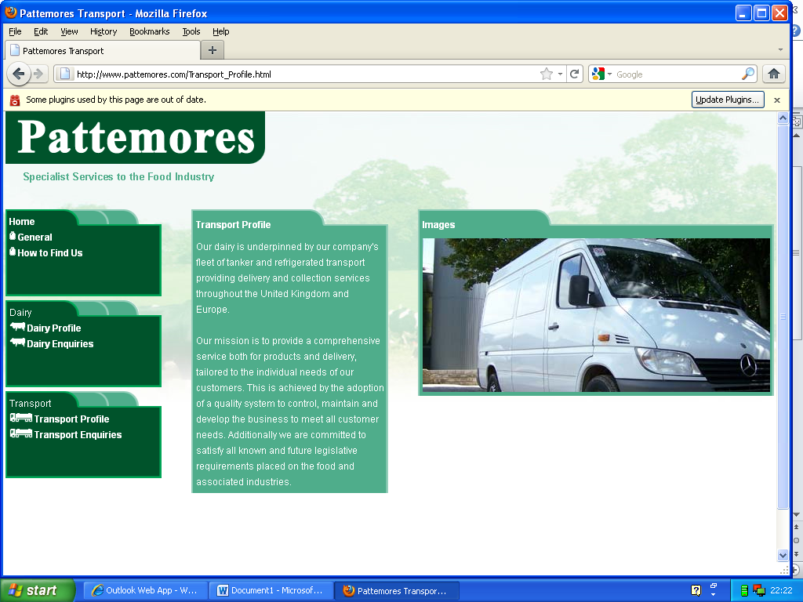**WATER TREATMENT PLANT OPERATOR**

Pattemores Dairy Ingredients have been established for over 80 years. We are a Medium sized, family owned and run business in the food manufacturing industry based on the Somerset / Dorset border just outside of Crewkerne.

We are a professional, customer-focused operation that produce quality dairy ingredients for the food industry.

Our staff members are dedicated to quality, accuracy, and prompt delivery of all orders. A successful candidate will have a strong work ethic as well as excellent communication, time management and problem-solving skills. We're looking for individuals who are excited about the opportunity to grow personally and professionally.

As a member of our team you will be entitled to the following benefits,

|  |  |
| --- | --- |
| * Casual dress | * Wellness and support program |
| * Company pension | * Training and development program |
| * Cycle to work scheme | * Employee of the month award |
| * On-site parking | * Christmas bonus |
| * Store discount | * Refer a friend bonus |

**Job Description**:

* Day to day running of the Water Treatment Plant.
* Plant compliant with Environment Agency discharge consent.
* Plant maintained within Health & Safety guidelines and relevant procedures.
* Escalation of any issues likely to impact continuity of plant operation.

**Responsibilities**:

* Ensure all daily routine duties are completed on time (e.g. interceptor pits)
* Resolve any basic issues by completing remedial maintenance work.
* Assist engineering team with routine maintenance.
* Complete timely, daily collection of sludge, wastewater and complete screening, collecting samples to check SS, COD, Ammonia, Phosphate, Chloride, pH Alkalinity etc at specified locations throughout the process.
* Maintain accurate sample records with details of actions taken.
* Ensure that any breaches of consent are immediately reported to management.
* Effectively manage stocks of chemicals and consumables, ensuring levels are monitored and topped up as required.
* Maintain Water Tratment Plant grounds and facilities to a clean, tidy and hygienic standard.
* Adhere to all set standards and procedures to ensure compliance
* Weekend working on a rota basis (currently 1 weekend in 4) with rest days and enhancements for Working Weekends/on call

**Skills**:

* A demonstrable mechanical understanding (basic maintenance experience preferable)
* Able to think logically with fault finding ability
* Reliable, enjoys taking responsibility
* As a lone worker, you will need to be self-starting and self-motivated
* Able to take the initiative and prioritise tasks according to schedules or deadlines
* Good communication skills